Laborator 6
1. HAL_GPIO_TogglePin(LED_GREEN_GPIO_Port, LED_GREEN_Pin);
HAL_Delay(500);

2. if (HAL_GPIO_ReadPin(GPIOC, GPIO_PIN_13) == GPIO_PIN_RESET)
{
// Button is pressed → blink LED on PA5
HAL_GPIO_TogglePin(GPIOA, GPIO_PIN_5);
HAL_Delay(200); // blink every 200ms
}
else
{
// Button released → make sure LED is OFF
HAL_GPIO_WritePin(GPIOA, GPIO_PIN_5, GPIO_PIN_RESET);
}
For mesuarments I used D13 pin. I configured the PicoScope to the desired amplitude of 5V and a time base of 1 s/div. I observed the signal using the PicoScope to verify its behavior. A timer of 200 ms was used between transitions to ensure consistent signal timing.
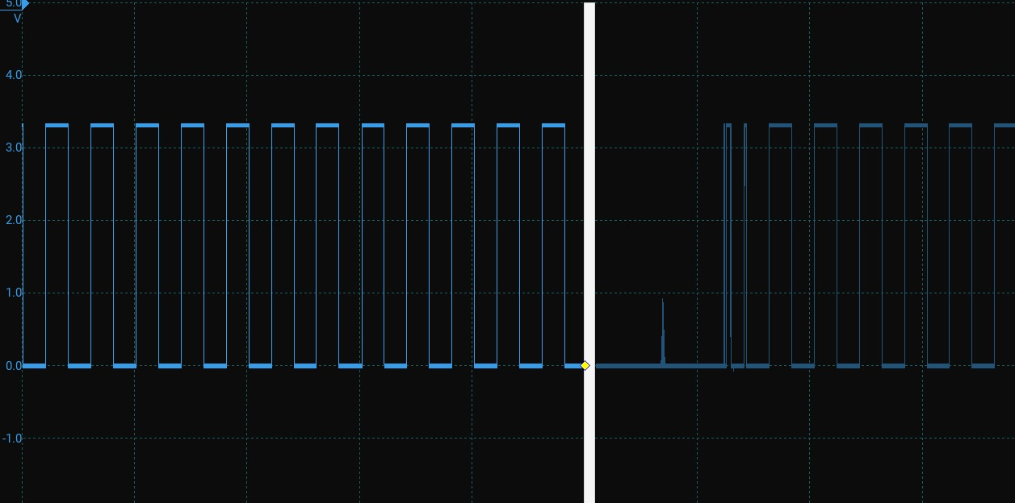

3. I chose the blue (USER) button because it is designed for user interaction and is connected to a configurable GPIO pin, allowing control of the application without affecting the system’s operation. In contrast, the black (RESET) button is strictly used for hardware reset and cannot be used for application logic.
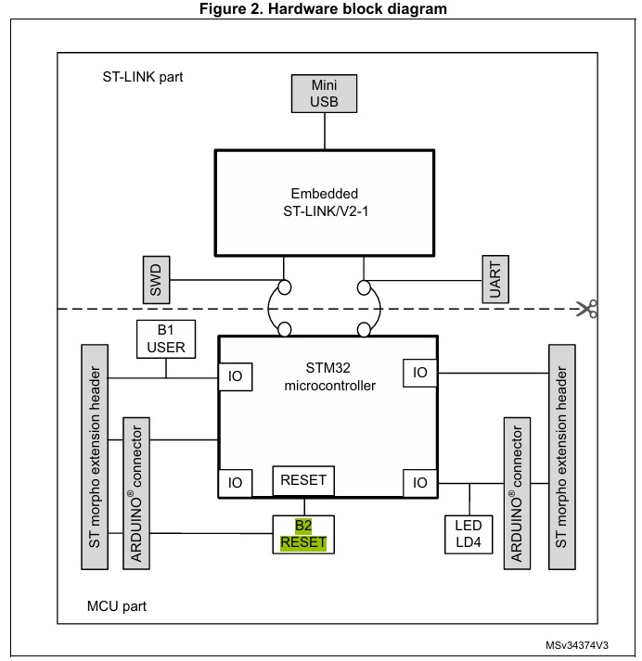
4. It is a very fast response.
